Top reviews from the United States

E. Kirchner-Dean

5.0 out of 5 stars Great for promoting sisterly love!
Reviewed in the United States on December 26, 2020
This was a sweet book that would be a perfect read for all those loving the mysteries of Halloween and wonderful lessons of nurturing and bonding between siblings. If you have two daughters you could read it to them together or perhaps to the older daughter who could get some great ideas! All in all it is a very enjoyable read!
One person found this helpful
Helpful
Report abuse

Keiko Wu

5.0 out of 5 stars The Story We Didn’t Know We Needed!
Reviewed in the United States on January 2, 2021
Verified Purchase
I love this book. I’ve ordered it twice and given both copies away. This book really fills a void for me. There are not enough sweet, heart-felt Halloween books (like this one) out there. And there are not enough stories about the power of loving kindness that can exist between siblings. The story and illustrations work together well here. I’ve worked in special ed and in main stream classrooms. I see a hundred books in a year. I’m ordering another copy of this one to help set a giving tone and gentle pace with the elementary kids at my school.
Thank you for your feedback.
Report abuse

Review #1: Review by Tiffany Ferrell
Reviewed By:
Tiffany Ferrell
Review Rating:
5 Stars - Congratulations on your 5-star review! Get your free 5-star seal!

Reviewed By Tiffany Ferrell for Readers’ Favorite
Full Moon is a Halloween story about two sisters who go trick or treating. As they wander around the neighborhood, they notice many kids dressed in all kinds of different costumes. While walking from house to house, the girls looked up at the night sky and wondered if there was really a man in the moon. Jessica asked her sister but she really wasn’t much help. She had so many questions about the person who apparently lived up there and it lasted throughout trick or treating to when they were at home, sorting out their candy. Deciding that the moon man needed her candy more, she collected it and wrote a letter to be given to the poor soul up there. Jessica hated to think of him having to eat moldy cheese all the time. After she sent it, she waited and hoped that the moon man got her care package. One day she found a letter underneath her pillow. She opened it to find out that he got the candy after all and was very grateful, which made Jessica’s day!
I always love reading Halloween stories and Full Moon is one of my favorites that I have read recently. It’s a story that will be very relatable to children. Halloween is a favorite day for kids because of trick or treating and then of course the myth of the man in the moon is something I think everyone has heard during their childhood. The different characters are well written and easily liked and the illustrations are beautifully done and go along perfectly with the storyline. It’s a great book that I definitely recommend parents get for their child.

Thank you!
Dec 8 at 3:56 AM
PrintRaw message

Renee Wright-Michaud <oceansedge2@hotmail.com>
To: ellenweis@yahoo.com <ellenweis@yahoo.com>
Hi, Ellen!
Just wanted to let you know that I received your holiday package! I LOVE the card, charm bracelet and book! I've read "Full Moon" and really enjoyed it - now I know what you are talking about! Such a cute story and yes, it gave me all the feels, just like your Uncle-in-law did. Thank you so much for thinking of me during the holidays! Wish we could get together, so that I could give you a big hug!
Thanks, again!
Hugs - Renee

Re: Your book, “Full Moon”
Dec 7 at 5:39 PM
PrintRaw message

David Acker <davidacker@comcast.net>
To: ellenweis@yahoo.com
Ken and Ellen
I am sending your book to my son, Joel’s children....young teenagers. I asked Joel if I could ask them two questions after they finish reading the book:
1. What did you think about the book
2. What/How did you feel after reading the book
I think the book may serve as an introduction to a conversation about cognitive and emotional responses.
Thank you again for sending the book to Eva and me.

David Acker

On Sunday, December 6, 2020, 07:04:36 PM EST, David Acker <davidacker@comcast.net> wrote:

Dear Ken and Ellen
I just finished reading the heart-warming story you wrote. As I neared the end of the story and read how you cleverly provided this adult reader with the clues of the similar-to-the older sister’s handwriting, my smile broadened and I finished the reading feeling the innocence of the younger sister and the love of the older sister. I had tears in my eyes and a broad smile. Thank you.
I wonder if my youngest grandchild, Adam, who just finished 6th grade is “too old” for this. Ironic that Adam’s grandfather (me) at age 77, enjoyed it thoroughly.
Eva hasn’t read it yet. When I showed her the book and told her my post-reading feelings, she said she has read many of your books and “that’s what they do, evoke feelings.”

Thank you.

David Acker
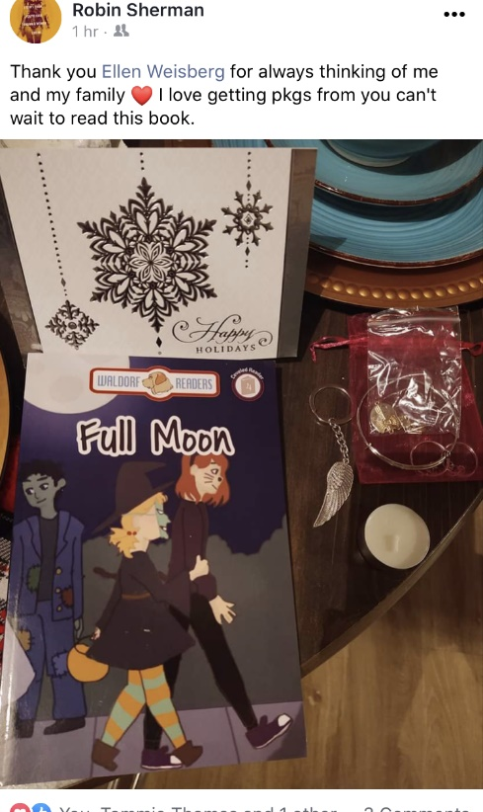
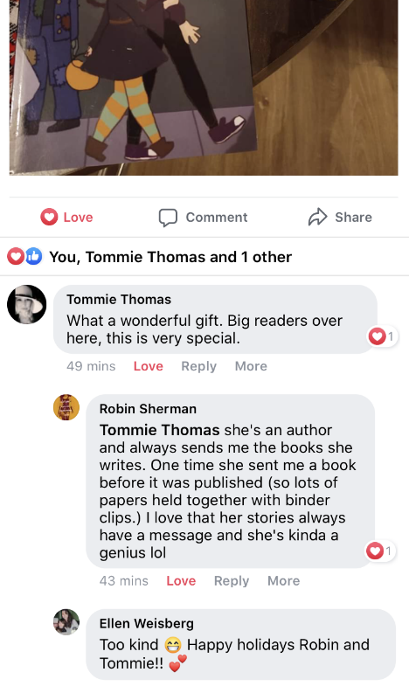
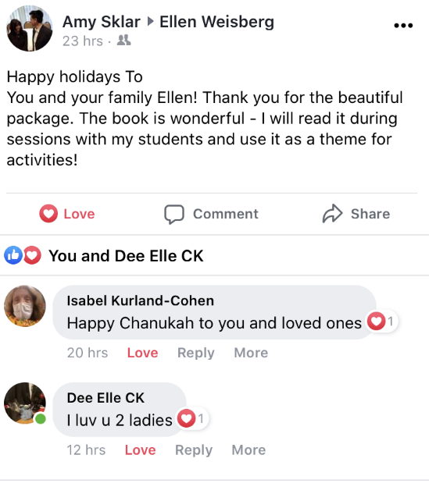
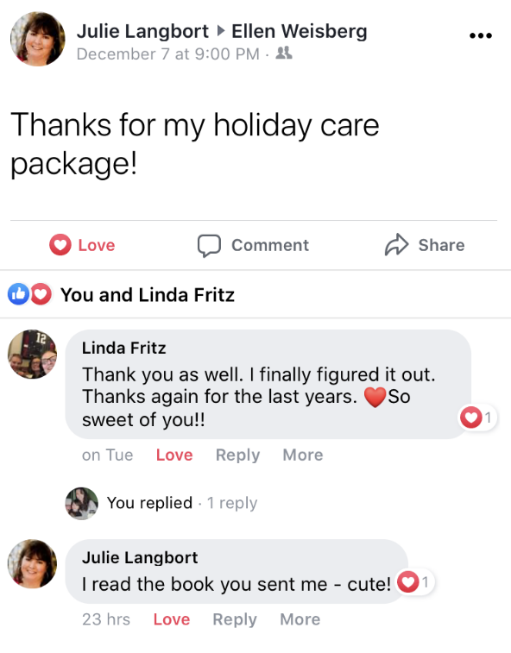
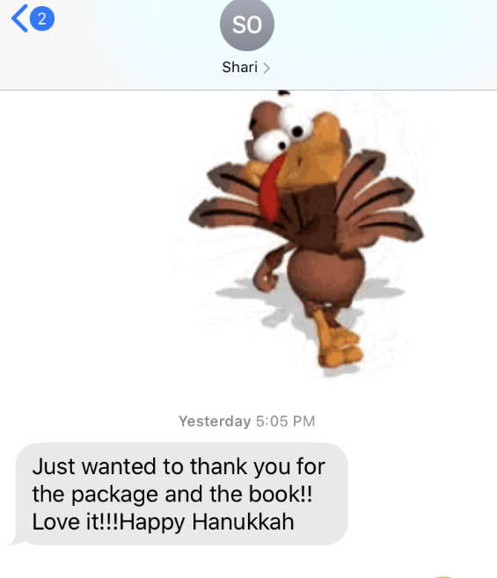
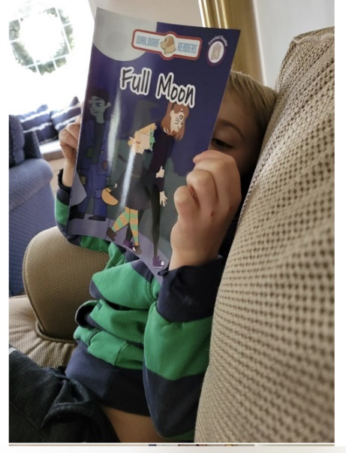
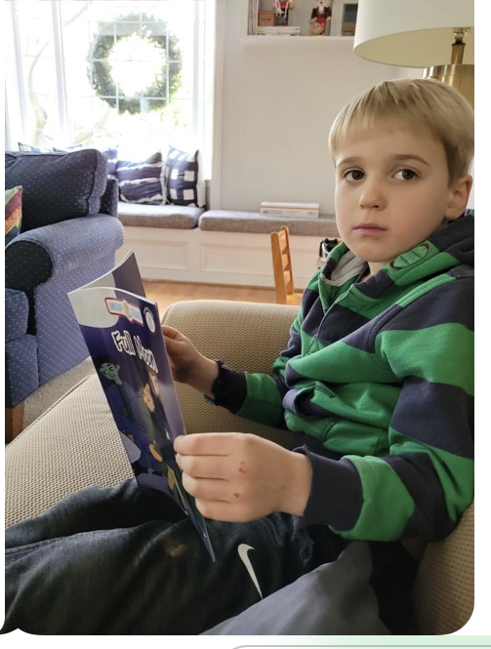
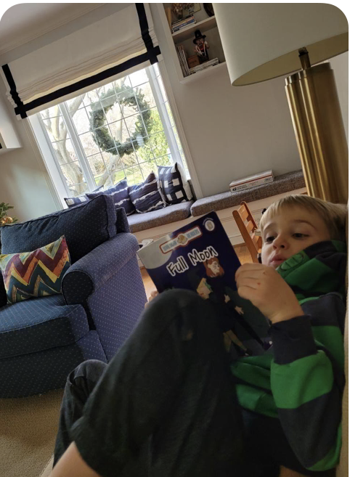
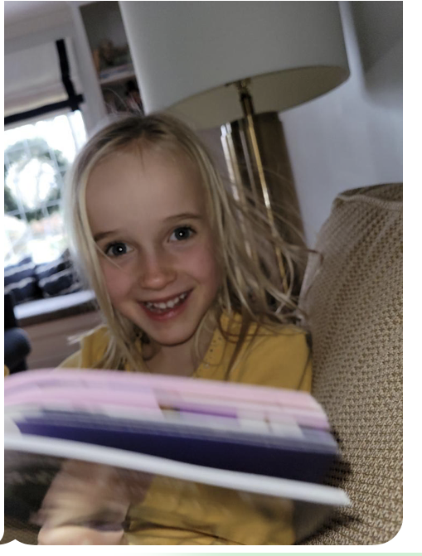
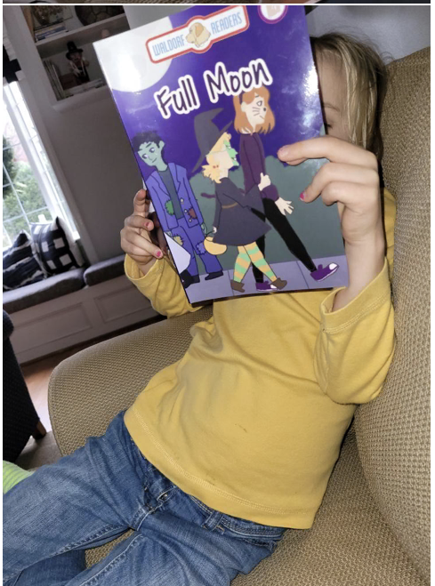
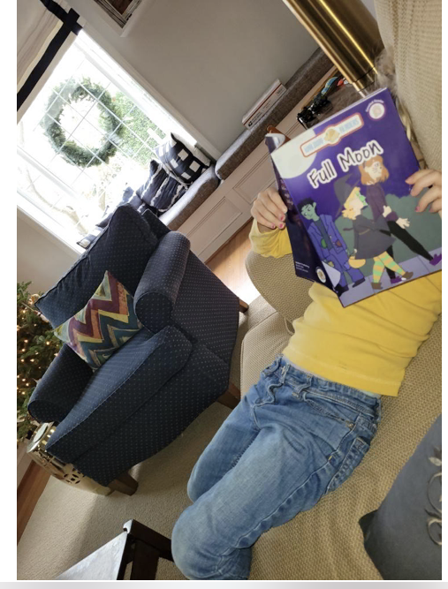
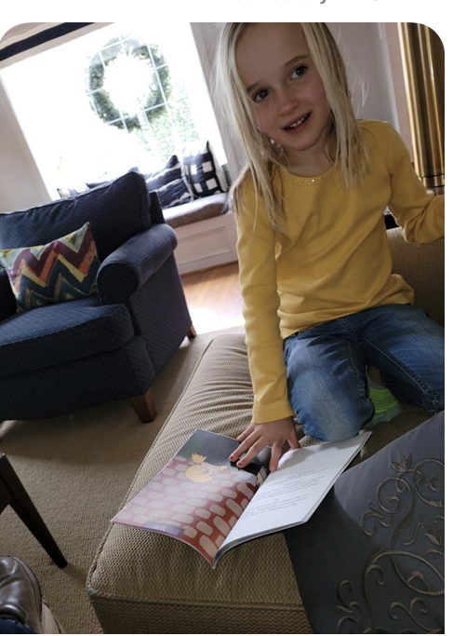
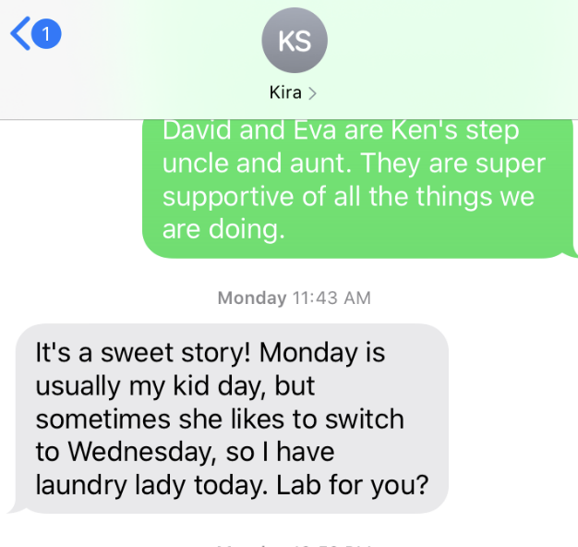
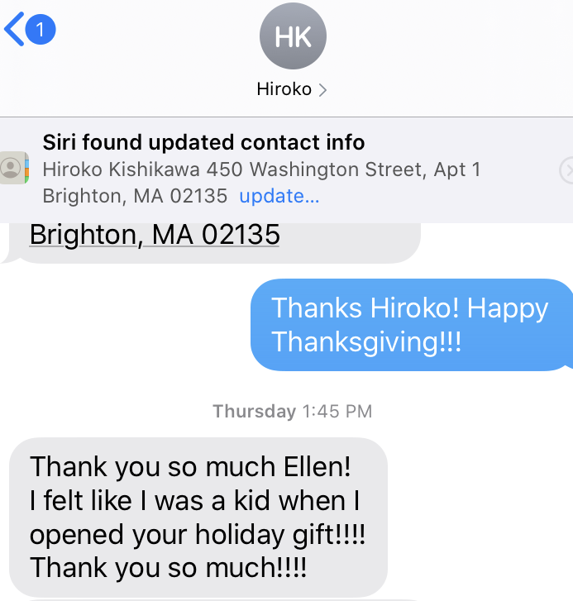
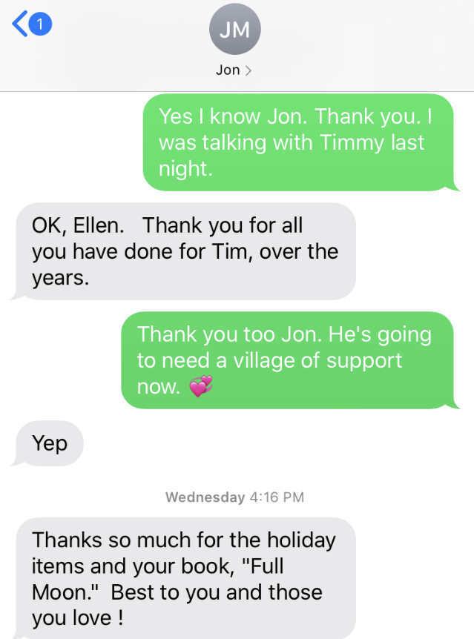
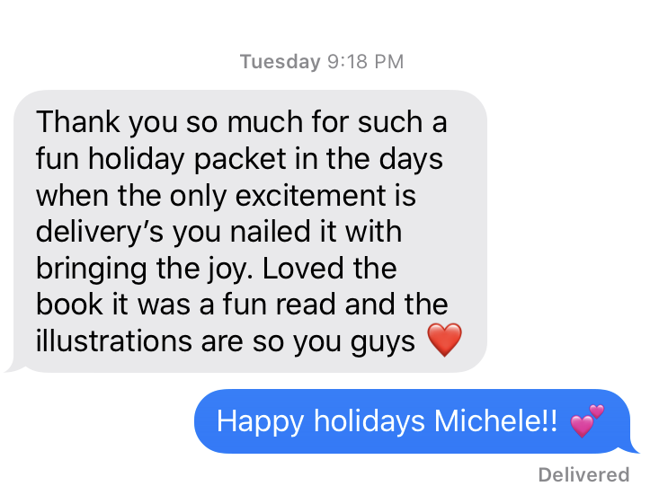
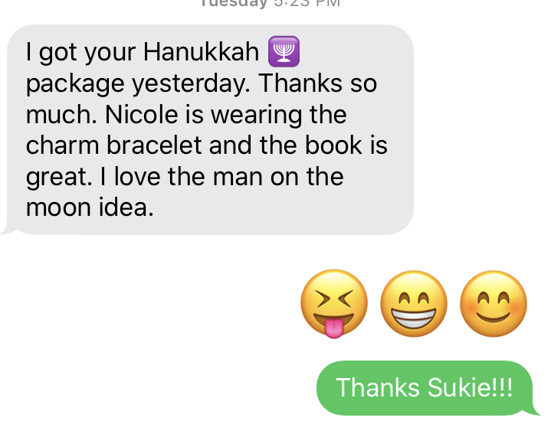
Cara Cavazza
I just wanted to send warm Hanukkah wishes for a happy celebration tonight . I received your lovely book and holiday gift which I look forward to every single year. You’re such a thoughtful and kind friend. I look forward to it truly so thank you so very much for thinking of me. I hope you, Ken, Emily and your family are doing well. So much going on these days I’m so much to catch up on… Just know I’m thinking of you 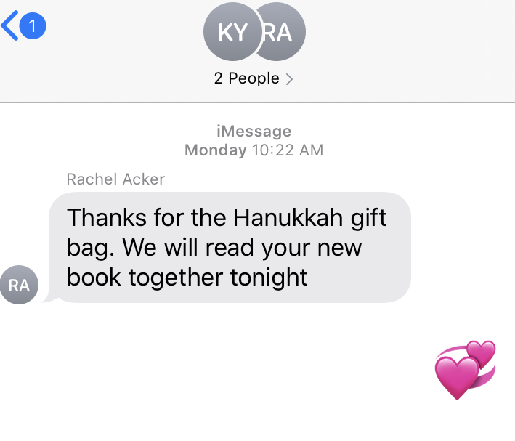
Rik Benson
Happy Hanukkah Ellen! Thank you for being such an inspiration and I hope you and your family enjoy the warmest of times the season has to offer!

Ann Kushner
Hi Ellen, What a wonderful surprise to receive your package in the mail with your book and the charms . Love the book. You are so talented and I am so proud of you. Thanks so much for thinking of me . How is your mother doing? Wishing you all a wonderful holiday. Love Ann

Thanks so much, Ellen, for the card, and your great book! So LOVELY!Happy Chanukah! Sending a hug, Karyn, Dennis, Eric, Tina and Martin.

David Kushner
Hi Ellen! We just got your new book today! Thank you! I let my daughter read it and she loved it! I hope all is well with you and your family!

Carol Croteau
Thank you for the beautiful holiday “card”. I wish you had autographed the book! Where can I buy these? Do you mind if I send this to my granddaughter? She just turn 2 and is very verbal and her parents tell us that all she wants is for them to read her books and then re read her books. My oldest daughter was this way too and There is this book call I Will Teach My Dog One Hundred Words. Almost 40 Years later I can still recite the first page. .

Holly Mello
Thank you Ellen... and thank you for your lovely gift in the mail it came yesterday

Re: review
Dec 12 at 12:55 PM
PrintRaw message

David Acker <davidacker@comcast.net>
To: Ellen Weisberg <ellenweis@yahoo.com>
Ellen
I would like to add my impressions to those of the reviewer.
I found the older sister’s act of love for her younger sister by writing a letter to her younger sister as if she was the man in the moon to be a powerful act of love. I sent the book to Joel and asked him to ask his children to read it and to be ready for grandpa’s questions.
I just finished talking to Adam. He is 12 years old. He summarized the facts of the story and then we started talking about our feelings about the older sister’s act of love for her younger sister as evidenced by her writing the note “from” the man in the moon. My response was emotionally stronger than Adam’s but he felt the emotional sisterly “love tug.” I will talk to Maddie tomorrow.
Bottom line: it is a beautiful book !!
David

Thank you for the Christmas goodies! I am Over the Moon overjoyed with your new book! And the print is large enough for me to read!

sent Today at 8:17 AM
Sisters are the best!!!
Erica Kirchner-Dean sent Today at 8:17 AM
I will provide a glowing review!

(Nancy Auriemma
Ellen, you are so thoughtful! Happy holidays to you and yours! Xo

You continue to fill my space with love, joy, sounds, wisdom through all the beauty you are. Thank you for being you and a part of me

Rhodella sent Today at 11:33 AM
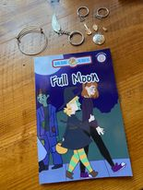

SG Da
I loved the book this year because I didn’t have to get deeply into it, I could just enjoy it, and the charms are pretty and precious, I will figure out as I’m not sure yet if I can reciprocate this year, but if not this year, another year! Thank you for thinking of me—perhaps you’d like my consciousness course, On Purpose Conscious, or maybe could use an architect? Either way, Happy Chanukah, Hug Sameach, and early Happy New Year 2021! With Love, SG/ Regina “Malka/Malky

Judy Halpert Robins

is feeling thankful.
5h ·
What a surprise from Dr
Ellen Weisberg
& hubby Dr Ken. A new children's book published. You two always amaze me. ((((HUGS)))) from Carolyn & Judy XOXO
Judy Halpert Robins
Thank you
Ellen Weisberg
for your thoughtfulness. Stay safe

amy calzonetti | 8:51 AM (9 hours ago)
to me

Hi Ellen,
Thank you for the holiday gifts. So thoughtful of you to remember me during the holidays. The book was great. I'll be sure to pass it along to a little one next Halloween so they can enjoy it too. I hope you and your family are doing well. Looks like we might be getting ready for our first significant snow fall for the season. I think the holidays always look better with a nice layer of white.
Again, thank you!! And wishing you and your family a very Happy Hanukkah!!
Amy

(Lauren Taub)
Hi Ellen! Hope you are doing well despite this very crazy year we certainly have had. Thanks so much for the card, beautiful bracelet with charms, votive candle, and your book! You are very talented my friend! It’s always such a nice surprise to get your package! Wishing you and your family a Happy Holiday and a Happy and Healthy New Year! XOXO

(Kiera Wood)
Hi Ellen, you are so kind ! You always send me something ! You don't need to but I am very grateful for your effort in sending me a present. This time is always so busy so please don't think you must . Thank you so much and I am so grateful for your effort and lovely gift . I hope you and family have a lovely Christmas time x

(Sandy Ferran Knapp)
You are always so thoughtful. Thank you.

(Jennifer Marlon)
Hi Ellen! I got your lovely holiday package and wonderful book - thank you! I love that you wrote a book about. microscopes - so cool to introduce kids to these amazing instruments. I'm so impressed by your energy and ability to do all of these things on top of your work and family responsibilities. How are you doing these days? This morning we are digging out - beautiful snow and happily no power outage. Did you get much snow? Remind me of which town you're in now... near Boston, right?

Thank you for book and pendants!
Dec 18 at 3:44 PM
PrintRaw message

LEA HOPE BECKER <leabecker2@comcast.net>
To: Ellen Weisberg <ellenweis@yahoo.com>
Ellen, I'm a bit late, but I think your package came a few days ago. I've already read the delightful book "Full Moon." Makes me think back to my childhood about the "cheese." I had an aunt who told me the moon was made of green cheese. I was about five years old and I figured she was kidding. I must have told her I didn't believe her -- how could that great big thing in the sky stay so big if it was made of cheese! Then, maybe on some occasion, like a birthday, she bought me a book entitled "Sun, Moon and Stars." It was more advanced, and she got me interested in astronomy. I didn't get to fantasize much about the moon once I learned about objects in the sky.

Is that why I'm more interested in science than in fables? And do you remember which books you read as a child?

Thank you so much for always being so helpful and creative and such a good friend.

Lea Becker

Full Moon
Dec 18 at 12:35 PM
PrintRaw message

Victor Gold <tantramanonline@yahoo.com>
To: Ellen Weisberg <ellenweis@yahoo.com>
Yo Ellen,
Happy holidays to you, Ken and Emily. Thank you for the sweet gifts and for remembering us. Aimee read Full Moon, and raved about the heartfelt story and the great illustrations. Very professional! You should be very proud. Your creativity is off the charts. Also, Sheila told me she is very grateful for your support. Your loving kindness has helped her have an easier transmission than she could have hoped for. I am very proud of you. Aimee and I send you all the love in the world. Keep the peace.

In gratitude,
V.G.

leona palmer | 12:45 PM (10 hours ago)
to me

Hi Ellen,

It's always great to re-connect and stay connected to friends. I value our friendship very highly.

Thanks for the holiday greeting and your new book - Full Moon - and all the other enclosed treasures. I really like the book - a great meaningful story and a fun read. I don't know how you do as much as you do.

I think Ken changed his email address a while back, and I don't think I have it. Will you please re-send his current email address? Thanks.

Wishing you, Ken and Emily a very special holiday season.
Stay safe

Lee

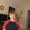
Lisa Kallianidis | 3:34 AM (19 hours ago)
to me

Cool! Where did she see your book?
Michael loves your latest book!

(Judy Rosenfeld)
Ellen, I just saw your message. I don't check Facebook that often. I can imagine how frustrating it was for you to not be able to hear and talk well on the call. I've had problems getting into calls a few times and it's been so frustrating to sit in front of a computer knowing everyone else is on it and you're not. We'll be having another call and hopefully that will work better for you. Karen told me that she's catching up with you on Christmas Day. That will be nice too. I hope you're doing well.
Did Karen tell you that I once came across one of your books? I looked at it and said I know someone named Ellen Weisberg and then I looked at the back of the book and it was you! Of course I bought the book. I showed it to Karen and she wanted it, so now she has it.

(Judy Moore)
Ellen, what a treat! I love your holiday charms and surprises. Love the book. The man on the moon can’t eat too much cheese because he’d be a cannibal! I thought the same thing when I was a kid. Very cute. Nick can’t wait to see it when he gets home. He’s intrigued you wrote books and got them published.

(Roberta DuBois)
Of a complete library I can't begin to thank you They are just fabulous books I've 2 nieces in Kingston that I know that will enjoy them and then they have to return To me I can't begin to say thank you to you the China book came with a charge of $25 Who do I make the check out to Brian's books are , pictures of mom and dad are perfect . Let's try to stay in touch. Would like to meet your family. Thank you again where do I send the ck.

David Acker | 3:46 PM (26 minutes ago)
to me

Ellen
Thank you.
Any new books coming from your (plural) brilliant minds?
Looking forward to resuming our dinner gatherings in late 2021-early 2022.
David Acker

